

**Department of Electronic & Telecommunication Engineering, University of Moratuwa, Sri Lanka.**

Guitar Headphone Amplifier

Group Members

**Core Four**

|  |  |  |
| --- | --- | --- |
|  | Name | Index Number |
| 1 | Perera P.D.P. | 210469G |
| 2 | Manatunge. J.M. | 210371A |
| 3 | Ranasinghe I.D.S.S. | 210517E |
| 4 | Rajapaksha S.D.Z. | 210508D |

Submitted in partial fulfillment of the requirements for the module EN 2091 Laboratory Practice and Projects

Date: 12/ 04/ 2023

# **Abstract**

**Objective:**

A guitar headphone amplifier serves as a vital accessory for both musicians and their surroundings, offering a host of advantages. Foremost, it prevents disturbances to neighbors or cohabitants, enabling late-night or private practice sessions without compromising harmony with the surroundings. Additionally, the amplifier eliminates the need to transport bulky amplifiers, providing musicians with unparalleled mobility and flexibility in their playing environments. Furthermore, this project mitigates potential hearing damage by allowing users to set controlled, safe listening levels directly through their headphones, promoting long-term auditory health. In doing so, it addresses not only convenience and consideration for others but also prioritizes the well-being of the user.

**Methodology:**  
In designing the electronic device, we employed Proteus for circuit simulation, Altium for PCB design, and SolidWorks for enclosure modeling. This integrated approach allowed us to validate the circuit virtually, optimize PCB layout, and ensure a precise fit of components within the enclosure. The use of these tools streamlined the development process, ensuring both functionality and manufacturability of the final product.

**Design Overview & Implementation:**  
Our electronic device features a class AB power amplifier, incorporating TIP41 and TIP42 transistors for efficient audio amplification. This design ensures a balance between the power efficiency of class B and the low distortion of class A amplifiers. Key components include a robust 9V battery, capacitors, resistors, and switches for reliable power supply, signal conditioning, and user control. The innovative aspect lies in the careful selection of components to achieve an optimal compromise between power consumption and audio fidelity. The class AB amplifier exhibits an approximate power efficiency ranging from 50% to 78%, depending on the specific implementation and operational conditions.

**Results:**

Reliable and distortion-free audio amplification. This successful testing underscores the efficiency improvements achieved, affirming the project's objective of balancing power efficiency and audio fidelity in the class AB amplifier implementation.

**Conclusion:**

The project achieved superior audio fidelity with minimal distortion in the class AB power amplifier, demonstrating efficiency improvements across various gain settings.

**Future Work:**  
Future enhancements may focus on size reduction for increased portability. Improved sound quality could be achieved by integrating differential amplifiers. Additionally, optimizing power efficiency by utilizing a single 9V battery and allowing customizable gain settings without range restrictions are potential avenues for further development.

List of Abbreviations

* AC Alternative current
* BJT Bipolar junction transistor
* DC Direct current
* DSP Digital signal processing
* FET Field-effect transistor
* PCB Printed circuit board.
* PWM Pulse width modulation
* RMS Root mean squar

Contents

**Abstract** 2

**1.** **Introduction and Functionality** 5

1. Introduction: 5

2. Functionality: 5

**2.** **System Architecture** 6

2.1 Table and Figure 6

2.2 Equations 7

2.2.1 Power calculations for class A , class B : 7

**3.** **Component Selection** 8

3.1 components 8

3.2 Bill of quantities 8

**4.** **PCB Design** 9

4.1 PCB footprints 9

4.2 PCB schematic 10

4.3 PCB Soldering 10

**5.** **Enclosure Design** 11

**6.** **Software Simulation and Hardware Testing** 14

6.1 Hybrid amplifier circuit schematics 14

6.2 Hybrid amplifier working flow 14

6.3 Bode Plots 16

6.4 Input Output characteristic & power consumption 18

**7.** **Conclusion & Future Works** 20

**8.** **Contribution of Group Members** 20

**9. References** 20

10.  **User Manuals and Datasheets**.…………………………………………………………………………………………………….20

# **Introduction and Functionality**

## Introduction:

An amplifier receives a signal from some pickup transducer or other input source and provides a larger version of the signal to some output device or to another amplifier stage. An input transducer signal is generally small (a few millivolts from a cassette or CD input, or a few microvolts from an antenna) and needs to be amplified sufficiently to operate an output device (speaker or other power-handling device). In small signal amplifiers, the main factors are usually amplification linearity and magnitude of gain. Since signal voltage and current are small in a small-signal amplifier, the amount of power-handling capacity and power efficiency are of little concern. A voltage amplifier provides voltage amplification primarily to increase the voltage of the input signal. Large-signal or power amplifiers, on the other hand, primarily provide sufficient power to an output load to drive a speaker or other power device, typically a few watts to tens of watts. One method used to categorize amplifiers is by class.

The class AB amplifier integrated into our guitar headphone amplifier represents an innovative leap in audio technology, striking an optimal balance between power efficiency and audio fidelity. This compact and portable device aims to redefine the guitarist's experience, offering a solution that combines low power consumption with an extended usage time, ensuring musicians can enjoy high-quality sound for prolonged sessions without the need for frequent battery replacements.

Class AB: An amplifier may be biased at a dc level above the zero base current level of class B and above one-half the supply voltage level of class A; this bias condition is class AB. Class AB operation still requires a push-pull connection to achieve a full output cycle, but the dc bias level is usually closer to the zero base current level for better power efficiency, as described shortly. For class AB operation, the output signal swing occurs between 180° and 360° and is neither class A nor class B operation [1].

## Functionality:

The class AB amplifier within the guitar headphone amplifier achieves remarkable power efficiencies, enhancing the overall performance of the device. By intelligently managing power consumption, it extends the usage time on a single 9V battery, providing musicians with a reliable and enduring solution. This innovation caters to the demands of both professional and aspiring guitarists, delivering an immersive sound experience with the convenience of extended playtime, making it an indispensable tool for practice, performance, and musical exploration.

# **System Architecture**

## Table and Figure

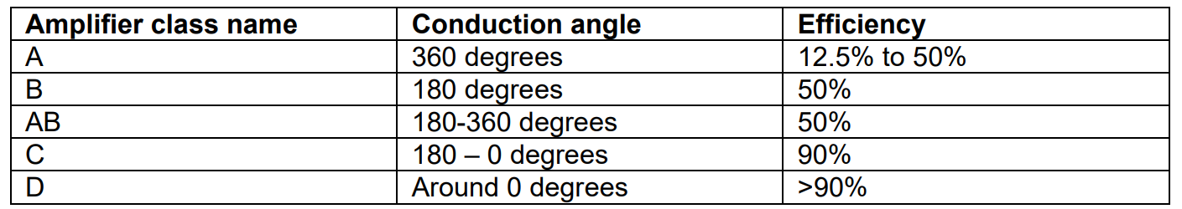On table 1 comparison of different amplifier classes efficiency and conduction angle are given. Efficiency is inversely proportional to the conduction angle of the circuit [2].

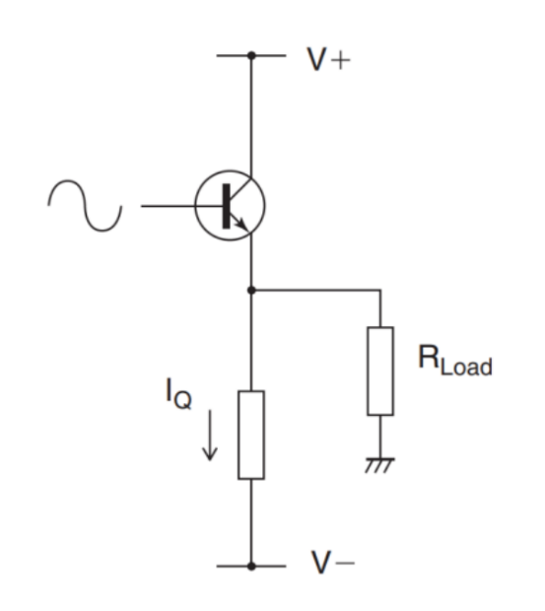

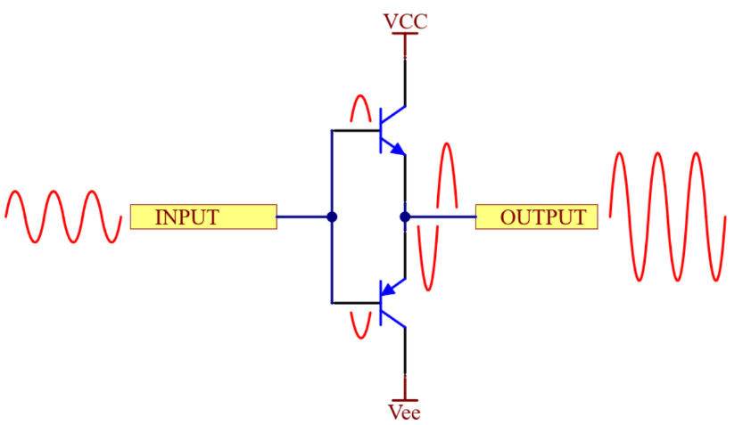

Fig 2.2 Class B amplifier

Fig 2.1 Class A Amplifier

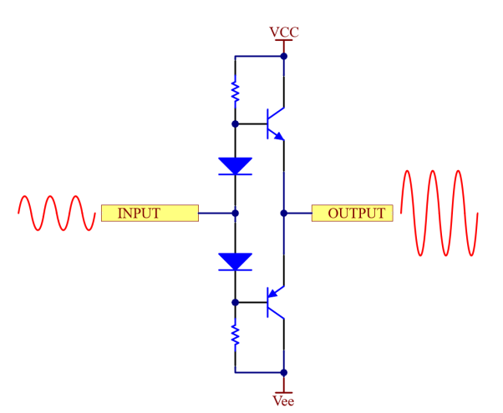

Class AB amplifier is a combination of A and B classes. The operation principle is similar for B class - each output device conducts part of the input signal, which combines to full sinewave on output. For **eliminating crossover distortion**, biasing points of each transistor are shifted from the center point, and the **devices have a small idle current flowing through them.**

Fig 2.3 Class AB amplifier

In our circuit we have used a hybrid circuit which is the cascaded version of operational amplifier circuit and a class AB amplifier which leads very power efficient amplifications.

**Hybrid amplifier circuit**

Headphones, unlike other audio devices, have very low impedance, usually around 16 Ω or more on each channel. Because of that special amplifying circuit is created. Figure 19 represents the hybrid amplifier circuit with the main parts commented. The working flow is represented in figure 20. It consists of two stages – an operational amplifier with a feedback circuit and the AB class power stage for feeding the signal with a current for low-impedance operation [4].

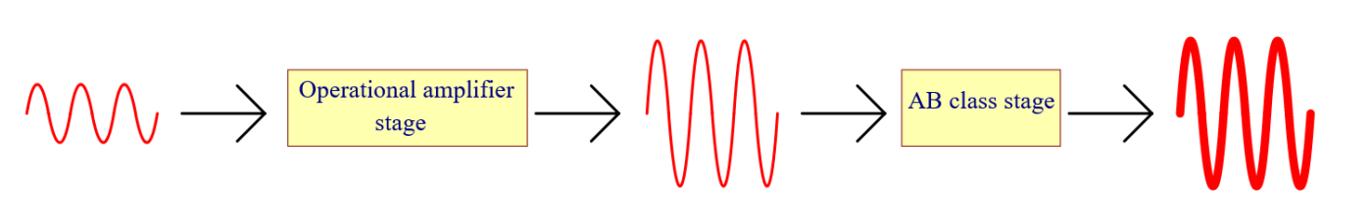

Fig 2.4 Hybrid Amplifier workflow

## Equations

### Power calculations for class A, class B:

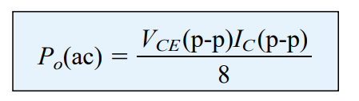class A: class B:

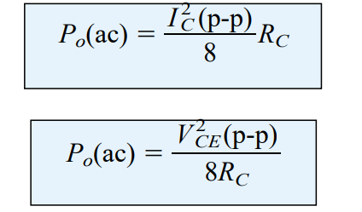

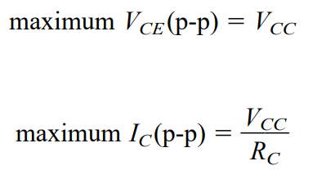

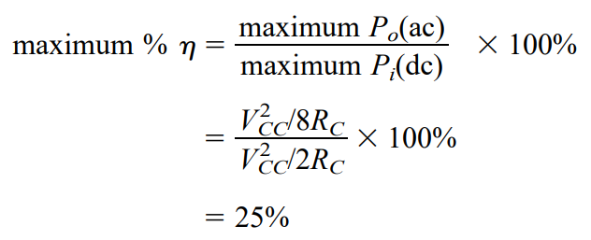

Therefore, use of these two classes as a hybrid can increase the efficiency even more with less distortions with compared to class C or D amplifiers

# **Component Selection**

## 3.1 components

* NE5532 OpAmp.
* Diodes.
* 100 ohm, 5kOhm , 2kOhm, 1 ohm, 4.7 kOhm , 2.2 kOhm, 10 kOhm resistors .
* 100uF, 33pF, 10uF DC blocking capacitors and coupling.
* TIP42, TIP41 power transistors, (BC558, BC547 : BJT).
* JST 2 pin female connectors, 3 pin female connectors.
* ON/OFF switch , and gain Switch (toggle).
* 3.5mm TRC female socket.
* 6.5mm mono audio female jack.

## 3.2 Bill of quantities

|  |  |  |
| --- | --- | --- |
| Component | Quantity | Price(Rs) |
| NE5532 | X1 | 35 |
| Diodes | X2 | 4 |
| Resistors | X10 | 10 |
| Transistors | X4 | 320 |
| JST connectors | X3 | 75 |
| Switches | X2 | 240 |
| 3.5mm TRC female socket | X1 | 120 |
| 6.5mm mono audio female socket | X1 | 40 |
| 6.5mm mono audio female jack | X1 | 350 |
| Mono Audio cable 1m | X1 | 130 |
| PCB printing | X1 | 1900 |
| Encloser Printing | X1 | 1500 |
| **Total** |  | **5024** |

# **PCB Design**

We used Altium software to design our PCB, and JLC PCB to print our PCB. These are schematics and footprints of the PCB .

## 4.1 PCB footprints

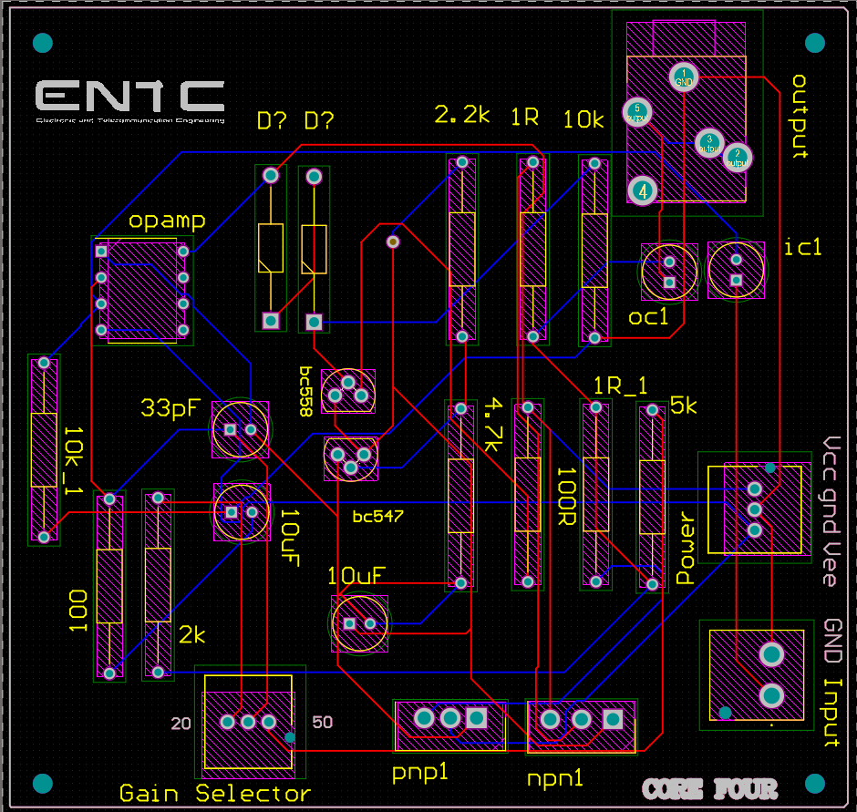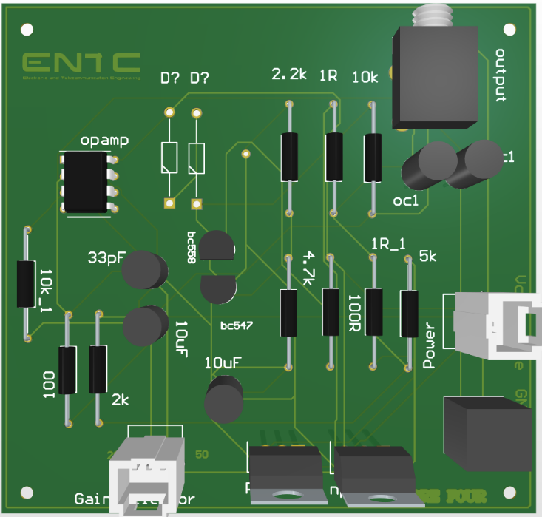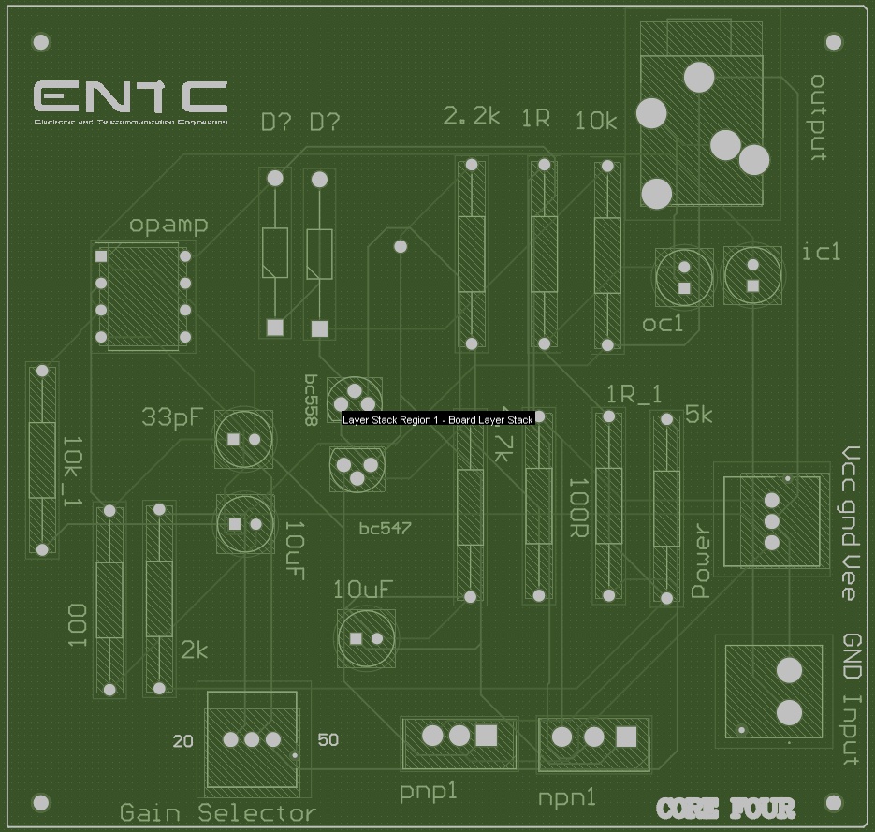

**Heat sinks**:

for TIP41 and TIP42 power transistors play a crucial role in dissipating heat generated during operation, preventing overheating, and ensuring optimal performance. These transistors are often paired with finned aluminum heat sinks, providing efficient thermal conductivity. The heat sink's design enhances the surface area for heat dissipation, maintaining the transistors within safe temperature limits and contributing to the longevity and reliability of electronic circuits. Proper heat sink selection and installation are essential for maximizing the power handling capabilities of TIP41 and TIP42 transistors in various applications.

## A diagram of a machine4.2 PCB schematic

## 4.3 PCB Soldering

When soldering, ensure a well-ventilated area and wear appropriate safety gear, including eye protection. Use the right soldering iron temperature and solder with caution, maintaining cleanliness to achieve reliable joints. Follow best practices, such as tinning the iron tip and avoiding excess solder to ensure a secure and clean soldering process. Always adhere to safety guidelines to protect both yourself and the electronic components.

# **Enclosure Design**

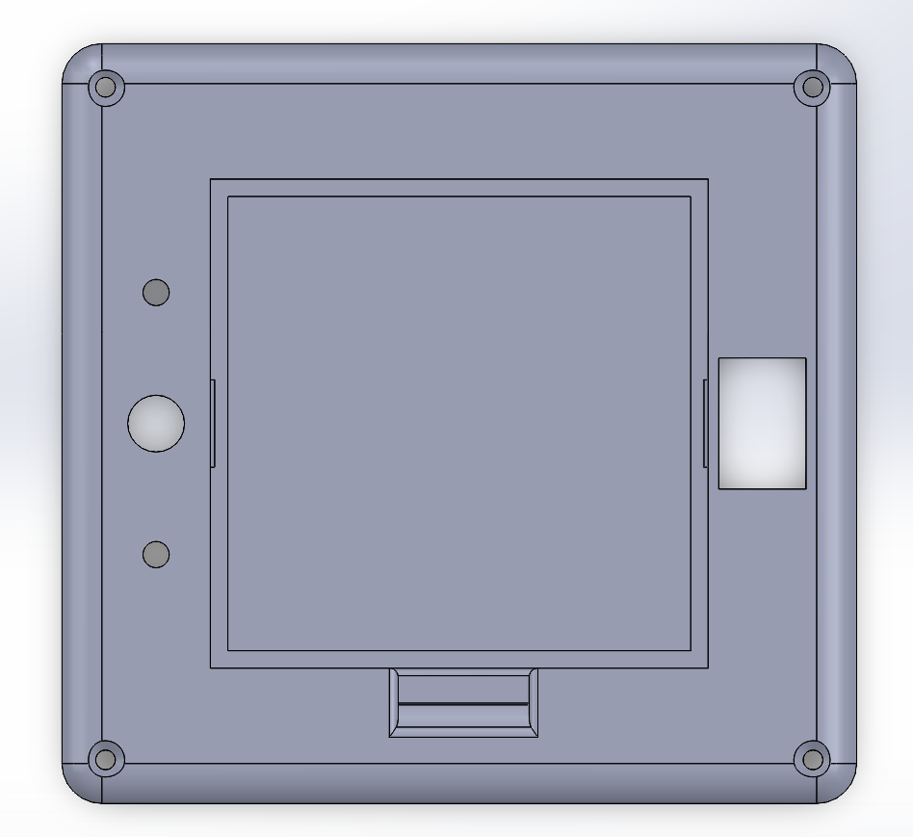In our project, we employed SolidWorks for precise three-dimensional modeling, ensuring optimal fit and functionality. The final design was materialized using ABS filament through 3D printing, enabling a durable and customizable enclosure that seamlessly integrates with the electronic device, providing both structural integrity and visual appeal. We incorporated 2mm screw holes for secure assembly, ensuring stability and ease of maintenance. Additionally, a dedicated pocket within the enclosure was specifically crafted to house 9V batteries, optimizing space and enhancing accessibility. This thoughtful integration enhances user convenience while maintaining the overall structural integrity of the electronic device.

Fig 5.1 Top View

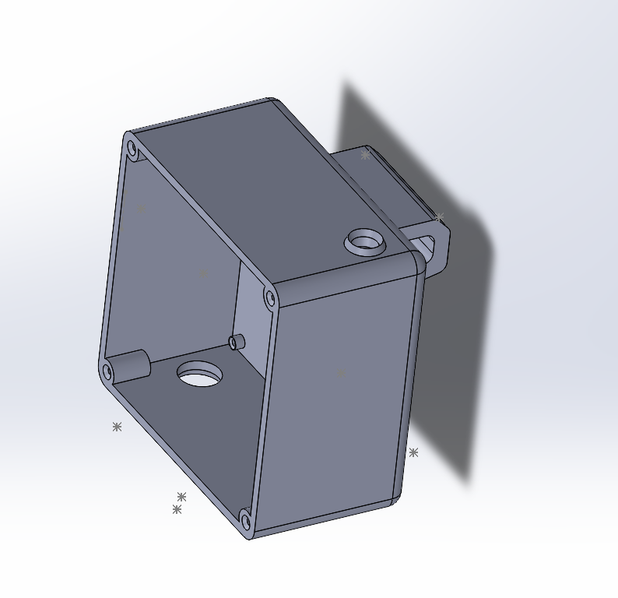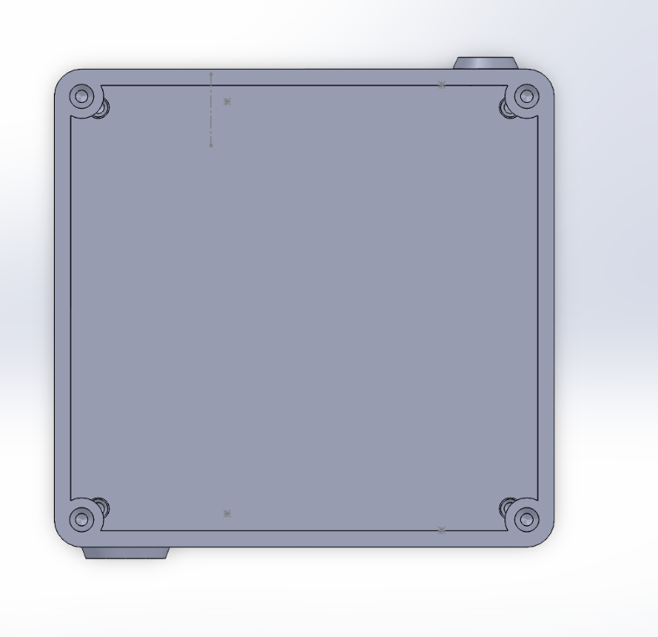

Fig 5.3 Side view without the lid

Fig 5.2 Top Inside View

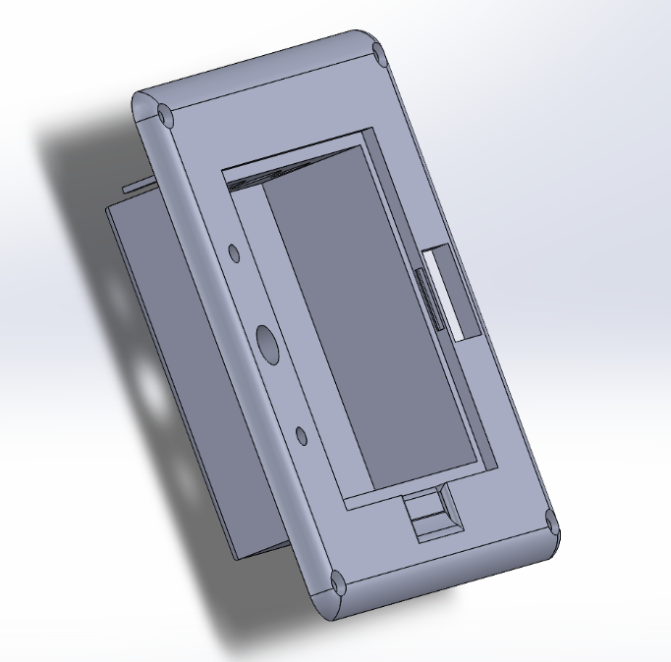

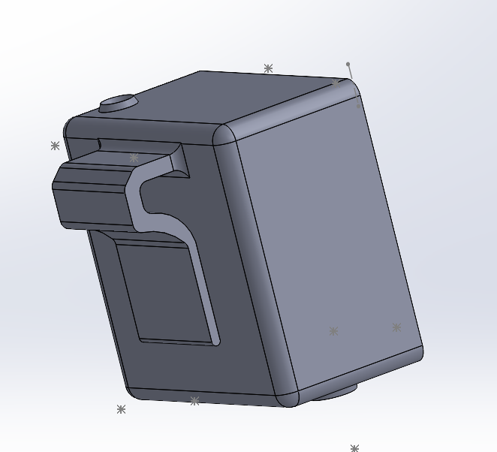

Fig 5.5 Rare View with the hanger

Fig 5.4 Lid and the Battery pocket

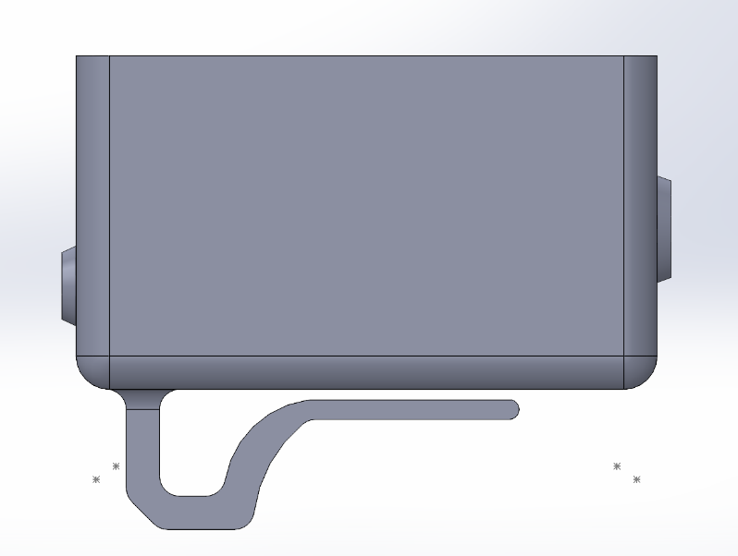

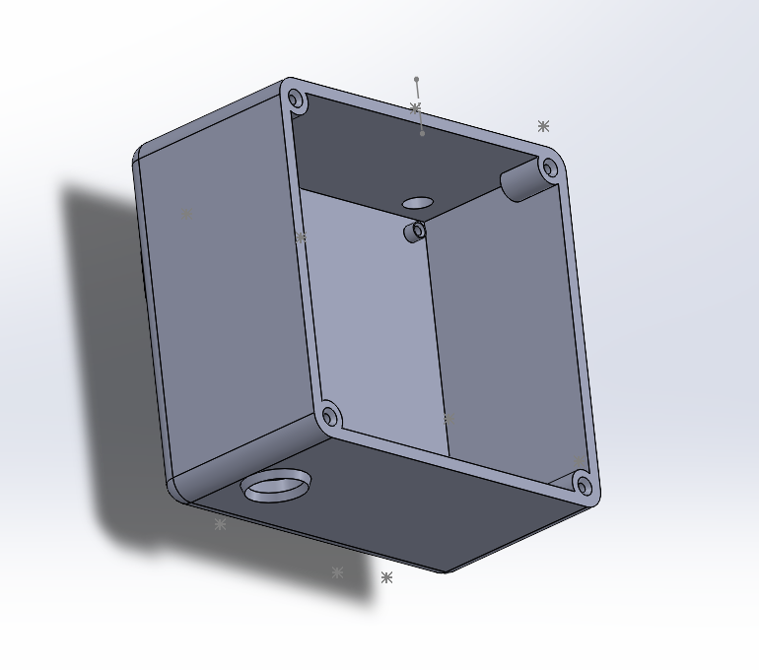

Fig 5.6 Side view

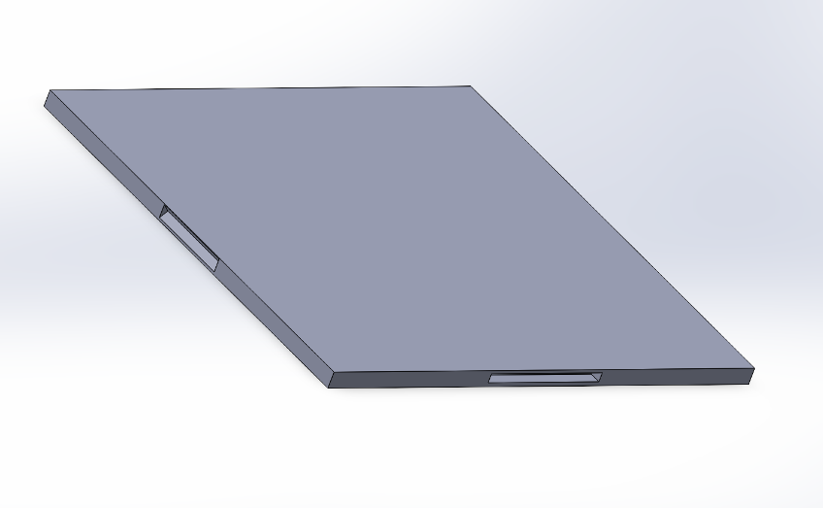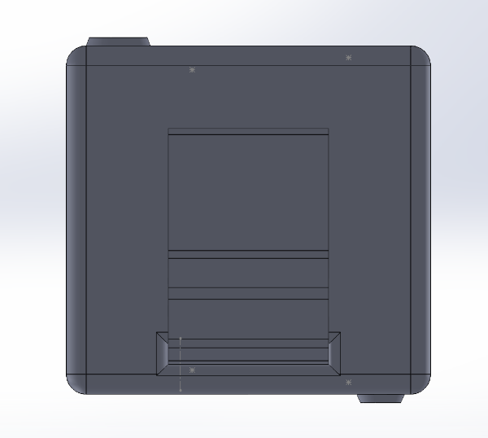

Fig 5.8 Battery pocket clip

Fig 5.7 Rare view

# **Software Simulation and Hardware Testing**

## Hybrid amplifier circuit schematics

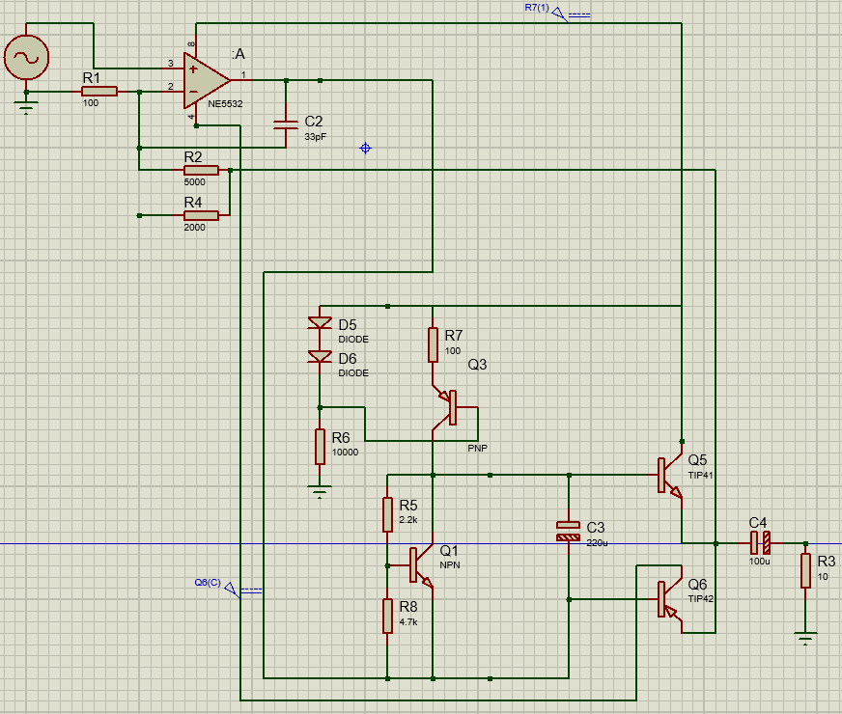 Low noise and due to high range of mid frequency gains we chose NE5532 Opamp to our Design.

Fig 6.1 Schematic Diagram

## Hybrid amplifier working flow

The operational amplifier section can be classified as a non-inverting operational amplifier circuit. Signal is fed to the non-inverting operational amplifier input, while the feedback circuit with voltage divider is connected to the inverting input of the operational amplifier. By changing resistor values, signal voltage difference can be tuned for needed gain values. Output voltage for such kind of circuits is calculated by formula 8.



In above circuit 2000ohm, 5000ohm are used with 100ohm to achieve 20 and 50 gains. The parallel feedback capacitor (C2 from figure) is placed for stabilizing the system of capacitive load is connected to the output. multiplier circuit for biasing the output transistors instead of diodes. As output transistors, TIP41 and TIP42 models are used in above circuit.

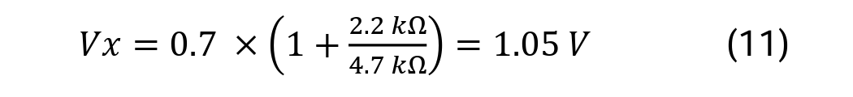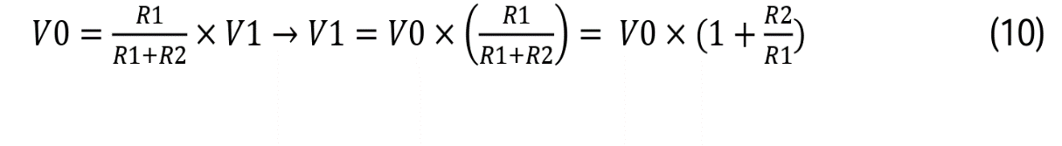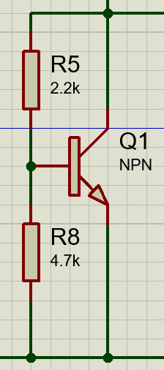

Fig 6.1 Vbe multiplier

Vbe multiplier (represented in figure) is a circuit, which consists of a bipolar junction transistor (BJT) and two resistors. Resistors operate as a voltage divider, which defines the multiplication factor of Vbe Voltage. Vbe multiplier voltages are calculated by equation (10). In analyzed circuit Vbe multiplier is driven by current source.

Considering V0 = Vbe = 0.7 V total voltage drop Vx in case of analyzed circuit values is calculated by equation (11).

It means that the voltage drop of 1.05 V is divided between both bases. Because of that, the base of each transistor is biased to approximately 0.5 V. C3 is placed for bypassing the Vbe multiplier and eliminating non-linearities on output transistors bases.

The biasing circuit (shown in figure), consisting of D5, D6, R6, and R7, works as a current source. Two 1N4148 diodes with approximately 0.6 V voltage drop on each placed for biasing PNP BC558 transistor, while the resistance value of R7, which is used to set the output current.

Output current is equal to the base current subtracted from the current through R7. As the base current is minimal, the output current is approximately the current through R4. Vbe voltage drop is around 0.7 V, so it can be compensated with the voltage drop across D6, while the voltage drops across D5, divided by R7 resistance, according to Ohms Law, gives the current in R7. Circuit voltages calculation is represented by equations (12), (13), and (14).

V(𝐷5) + V(𝐷6) = V𝑏𝑒 + 𝑉(𝑅7) → V(𝑅7) = V(𝐷5) + V(𝐷6) − V𝑏𝑒 (12)

V(𝐷5) = V(𝐷6) = V𝑏𝑒 = 0.7V (13)

V(𝑅7) = 𝑅7 × 𝐼(𝑅7) (14)

For proper device operation, the output current should be tuned to less than half the maximum output current of the operational amplifier, which sinks the current. This also biases the operational amplifier to the AB class. R4 resistors are so-called emitter degeneration resistors. During operation, transistors start to accumulate heat, and, because of that, the biasing point will flow around standard 0.7 V, causing system instability. By adding small value resistors (1Ω in the given circuit), heat dissipation will be reduced.

## Bode Plots

Bode plots serve as powerful tools for visualizing the system's frequency response. These plots succinctly depict the magnitude and phase characteristics, offering valuable insights into the system's behavior. Through Bode analysis, we gain a clear understanding of how our system responds to varying frequencies.

We used LT Spice circuit simulation software to analyses our circuit’s bode plots. Below are the gain plots for 20 and 50 separately.

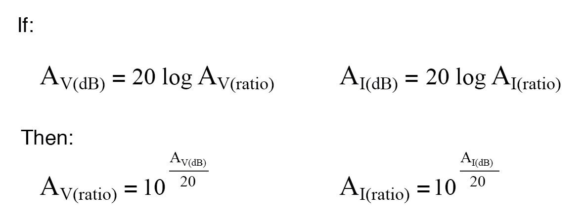

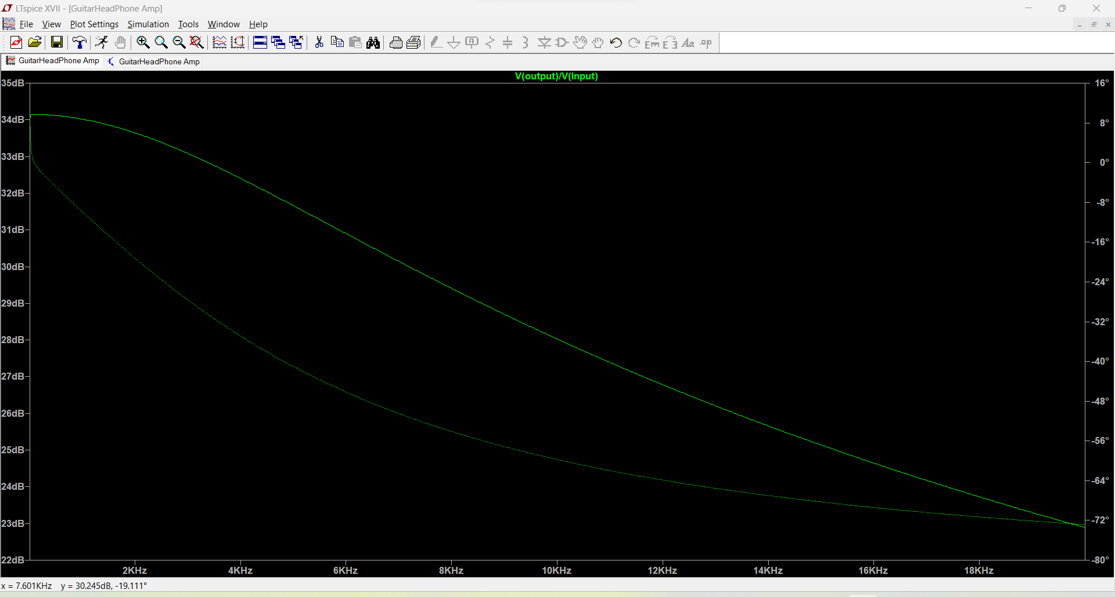

Fig 6.2 Gain plot for 50

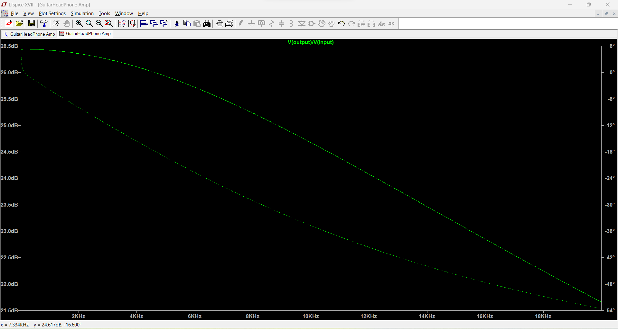

Fig 6.3 Gain plot for 20

## Input Output characteristic & power consumption

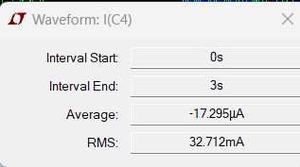

* According to the above graphs RMS current is 32.712mA.
* 400mAh capacity battery each.
* Therefore, Average use time is approximately 24 hrs.

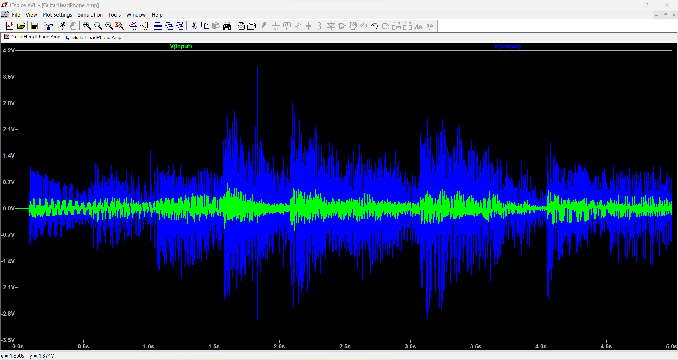

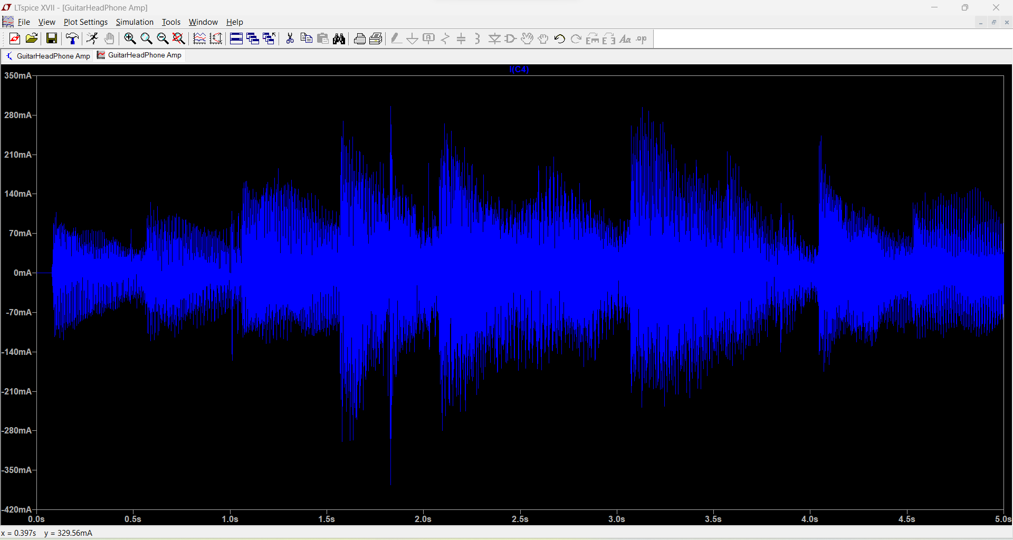

Fig 6.4 Input output characteristics

Fig 6.5 Output current with 10-ohm load.

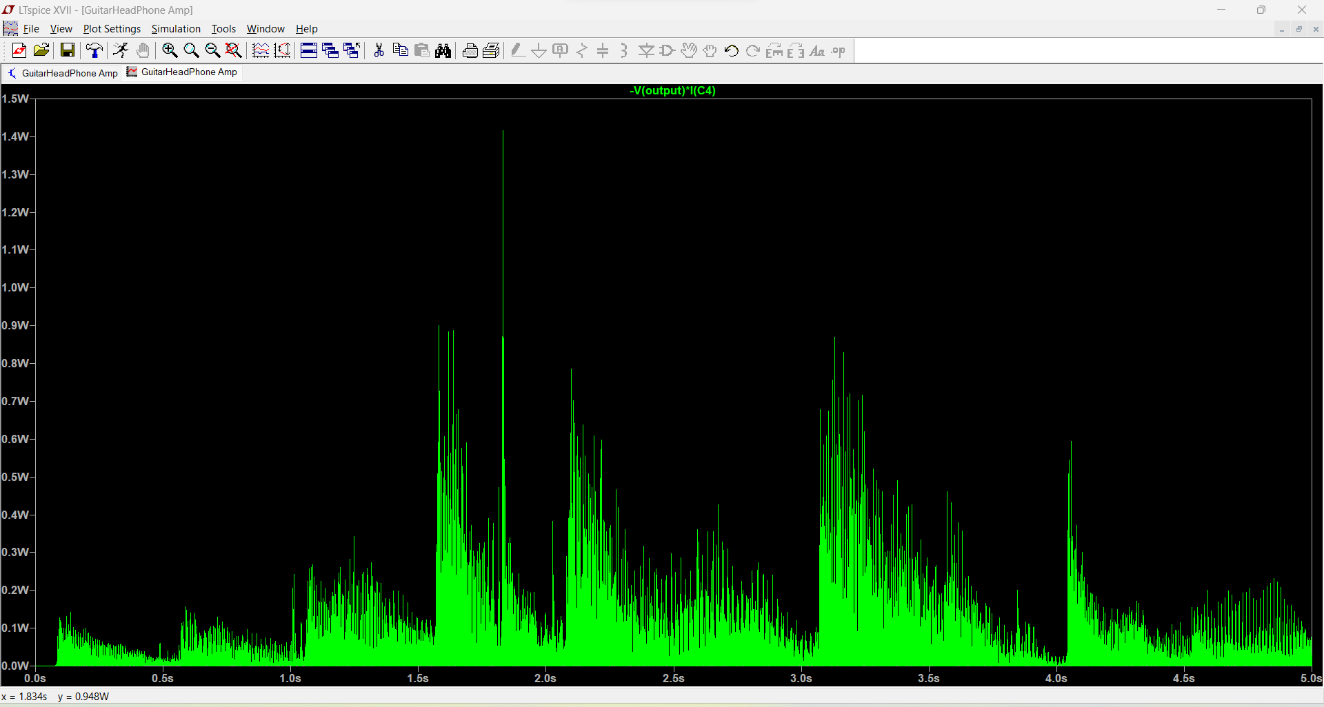

Fig 6.6 Power curve

# **Conclusion & Future Works**

Our future work focuses on enhancing the project in various aspects. We aim to optimize the enclosure size for practicality, refine circuit design by incorporating LED bulbs for gain indication, introduce a rocker for customizable gain settings, and employ differential amplifiers to elevate sound quality. Additionally, we plan to incorporate auxiliary input capability, achieve low power consumption, reduce weight, and ensure an externally user-friendly structure for an overall improved user experience.

# **Contribution of Group Members**

|  |  |
| --- | --- |
| Name | Contribution |
| Shenal Ranasinghe | Altium PCB Designing |
| Dineth Perera & Selaka Rajapaksha | Circuit Designing |
| Javin Manatunge | SolidWorks Enclosure Designing |
| Entire Team | Documentation and Testing |

# **References**

[1] W.H. Hayt and G.W. Neudeck, Electronic Circuit Analysis and Design, 2nd ed., Boston: Houghton Mifflin Go., 1984.

[2] R.C Jaeger and T.N. Blalock, Microelectronic Circuit Design, 2nd ed., New York: McGraw-Hill, 2004.

[3] E.J. Kennedy, Operational Amplifier Circuits: Theory and Applications, New York: Holt, Rinehart and Winston, 1988

[4] A. S. Sedra and K. C. Smith, Microelectronic Circuits, 7th ed. Oxford University Press, 2014, textbook widely used for learning microelectronic circuits.

# **User Manuals and Datasheets Used**

1. TIP41 - <https://www.mouser.com/datasheet/2/149/TIP41C-890135.pdf>
2. TIP42 - <https://www.mouser.com/datasheet/2/149/TIP41C-890135.pdf>
3. BC547 - <https://www.mouser.com/datasheet/2/149/BC547-190204.pdf>
4. NE5532 - <https://www.ti.com/lit/ds/symlink/ne5532.pdf?HQS=dis-mous-null-mousermode-dsf-pf-null-wwe&ts=1701884387455&ref_url=https%253A%252F%252Fwww.mouser.in%252F>

How to use our device:

1. First connect the guitar cable to the port.
2. Then connect a pair of headphones to the 3.5 mm Jack port.
3. Select the desired gain of 20 or 50 using the toggle switch.
4. Insert two 9V batteries into the battery slots and turn on the device using the power switch.
5. Enjoy the music!